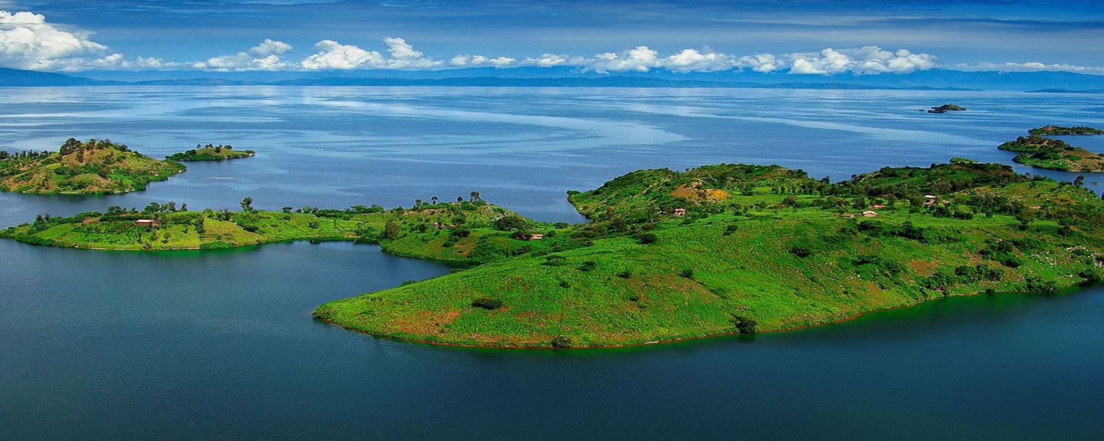  AN INCEPTION REPORT TO CONDUCT AN ECOTOURISM COST EFFECTIVE ANALYSIS TO IDENTIFY THE ANTICIPATED ECONOMIC IMPACTFUL INNOVATIONS AND THE FUNDAMENTAL BASIS OF MOST PROFITABLE LAKE WATER BUSINESS ON THE 5 IDENTIFIED LAKES IN RWANDA (KIVU, MUHAZI, BURERA, RUHONDO AND MUGESERA) | Barrack Manono& Festus Maina

Introduction
The purpose of this Inception Report is to outline the scope, objectives, and methodology for an Eco-tourism cost effective analysis to identify the anticipated economic impactful innovations and the fundamental basis of most profitable Lake Water businesses in Rwanda for five identified Lakes (Kivu, Muhazi, Burera, Ruhondo, and Mugesera). The report aims to provide a clear understanding of the project to all stakeholders, including the client, project team, and any third-party participants.
Scope
The project will focus on analysing the economic viability of eco-tourism and water-based businesses around the five identified lakes in Rwanda. The analysis will include a review of current eco-tourism and water-based businesses, identification of potential innovative ideas, and a cost-benefit analysis of the most profitable businesses. The project will not cover land-based businesses and activities.
Objectives
The objectives of this project are as follows:
1. To identify and assess the current trend the most profitable lake water-based businesses in Rwanda, with a focus on Kivu, Muhazi, Burera, Ruhondo, and Mugesera.
2. To identify and evaluate innovative ideas that could have a significant Social, economic and environmental impact on eco-tourism and lake water-based businesses and conduct a cost benefit analysis to reduce the negative impacts.
3. To provide recommendations for the most effective and sustainable eco-tourism and lake water-based businesses in Rwanda.
Methodology
The following methodology will be used in this project:
1. Desk research: A review of existing literature, reports, and other relevant documents will be conducted to identify current eco-tourism and lake water-based businesses in Rwanda and the region. Base line data collection and baseline data Gap analysis. (Man report in consideration the CBTEs report of 2022 and the Rwanda tourism Strategic plan)
2. Field research: Interviews and consultations will be conducted with relevant stakeholders, including government officials, business owners, investors, and tourists, to gather information on current and potential eco-tourism and lake water-based businesses in Rwanda.
3. Cost-benefit analysis: A cost-benefit analysis will be conducted on the identified eco-tourism and lake water-based businesses to determine their profitability and sustainability, taking into account factors such as investment costs, operational costs, and potential revenue streams.
4. Innovation assessment: Innovative ideas for eco-tourism and lake water-based businesses will be identified and evaluated for their potential economic impact, feasibility, and sustainability.
Deliverables
The following deliverables will be produced as part of this project:
1. An Interim report summarizing the findings of the desk and field research, including an analysis of the current eco-tourism and lake water-based businesses in Rwanda.
2. A report on innovative ideas for eco-tourism and lake water-based businesses with a significant economic impact. A cost-benefit analysis report of the most profitable eco-tourism and lake water-based businesses calculating NPV, BCR IRR
3. A final report providing recommendations for the most effective and sustainable eco-tourism and lake water-based businesses in Rwanda.
Timeline
The project is expected to take six months, starting in July 2023 and ending in December 2023. The timeline for each deliverable is as follows:
1. Inception and interim research report – 18/6/2023
2. Draft Report- 12/7/2023
3. Final report with recommendations – August 2023
Roles and Responsibilities
The project team will be composed of the lead consultant Festus Maina and Barrack Manono An assistant consultant.
Risks and Assumptions
The following risks and assumptions have been identified for this project:
1. Risk: Limited availability of data for analysis may impact the accuracy of results.
Mitigation: The research team will collect data from various sources to ensure accuracy and completeness.
2. Risk: Unforeseen changes in government policies or regulations may affect the viability of identified businesses.
Mitigation: The project team will monitor any changes in policies and regulations and make necessary adjustments to the analysis and recommendations.
3. and lake water-based businesses in Rwanda.
Mitigation: The team will conduct market research to validate this assumption and adjust the analysis.

