Dr. SandeepPandeyBiography
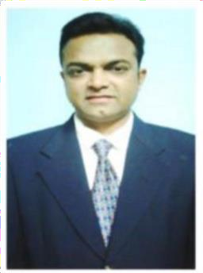
Dr. Sandeep Pandey
Senior Consultant, CoE-SLM,
ICFRE, Dehradun, Uttarakhand, India
Dr. Sandeep Pandey started his career as a Lecturer at CHM College, Ulhasnagar, Mumbai, India in 2001. He worked as a Lecturer in Botany at BNN College, Bhiwandi, and Siddharth College Art Science & Commerce, Mumbai, Maharastra, India. He joined the Department of Environmental Biology, A. P. S University, Rewa, (M. P.) India in the year 2005, worked as a faculty in M.Sc./M.Phil. Biotechnology, Environmental Sciences, Forestry and Botany up to year 2021. At present he is working as Senior Consultant, Centre of Excellence, Sustainable Land Management, Indian Council of Forestry and Education, Dehradun, Uttarakhandw.e.f 30th November, 2022. His area of research includes Botany, Plant Pathology, Environmental Biology, Ethnobotany, Forestry, Environment Management, Bioinformatics, and Nanotech sciences. He has published almost 51 research papers, attended more than 70 International and National Conferences in India and abroad.He has also been appointed Editorial member of Journals of repute. He initiated the "GREEN AMBULANCE" campaign during the UNO Biodiversity decade 2010-2020, with an aim to preserve native, rare and endangered plant species of the Vindhya region, Central India. The campaign planted more than 1000 plants in various Schools, Institutions, Govt. offices, Private lands to raise awareness among the communities. Dr. Pandeyhas bagged prestigious awards in the field of Science. He has received the National best research paper award in Siliguri (W.B.) and the International Best Researcher Awards in the Conferences held in Jabalpur (M.P.), and Chennai (T.N.).Hehas also been awarded the Best oral presentation in 4TH ACSTM, Dubai, UAE, November 2021, for his innovative research work on Medicinal Plants to cure SARS-COV-2 Virus. He was also honored with Excellence Award in Plant Science Research 2022, by AI-Global Media, Staffordshire, England. He actively participated in various social activities awareness programs for girl child education and health, blood donation camps, and awareness drive to educate weaker section of the society.

