Shan Yoma Travel & Tours has been in the Tourism Industry of Myanmar for more than 24 years striving for its excellence in services. Although there are many ups and downs all the way but the momentum and passion which drive Shan Yoma to keep on striving until today. Tourism is a smokeless industry and potential for earning high revenue for the country as well as multiplier benefit for all levels of people. Now that the trends are changing in promoting the country and destinations, creation and innovation of new tourism products are also one of the important key roles for the competitiveness besides the existing products. Therefore, Shan Yoma Travel and Tours is trying hard to create new products, new destinations to attract more tourists to Myanmar.
1996 was the “Visit Myanmar Year”, since then tourism promotions were being done focusing on Culture, Historical, Heritage, Community Based Tourism, Eco Tourism, Adventure and Nature based tourism. Besides the above mentioned activities, Shan Yoma has started participating in the activities of responsibility and sustainability which will impact on the environment and benefits for the communities.
Shan Yoma Travel and Tours company has done following policies for the organization to follow.
- Has create an effective environmental policy which sets clear directions to follow.
- Will carry out audit of it’s organization’s activities to identify area of improvement and environmental legislation that applies.
- Established operational procedures and control of implement the environmental policy properly
- Allocate environmental responsibilities
- Giving trainings to the staff.
- Review environmental performance on a regular basis to check whether the system is achieving the requested results.
- Participated in trainings given by Travelife, which is a leading training, management and certification initiative for tourism companies committed to reaching sustainability.
Operating business in a socially and environmentally friendly manner makes good business sense! Both consumer and business demand for responsible products is growing and the public wants to know how to manage the business.
Companies ready to get to work towards sustainability will, therefore, score better on customer satisfaction, staff motivation and business efficiency with positive effects for their competitive advantage. Sustainability management is all about commitment and consistent sustainable business practices. This includes products, how you monitor and manage impacts, and how you support your suppliers on their road to sustainability.
Shan Yoma became Travelife partnership after passing the 100 criteria in December 2019.. Now continue working hard to get the certification.
- Earth Hours 2020: Business for Nature challenge and for their commitment towards helping their employees connect to and product nature.
“Hero Award “2020. Participation in competition
- Sharing knowledge on Responsible and Sustainable practices

- Union of Myanmar Travel Association, Topic on The Importance of Sustainability 11th Jan ’20.
- University of Foreign Languages (Yangon) Webinar in May’20
- As a speaker for ASEAN TIME in June 2019 in Thailand.
- As a speaker for National Conference on Communities and Tourism June’ 2019.
- As a speaker, Topic on Destination Management in Myanmar Tourism Conference 12th June’2018.
- Corporate Social Responsibility activities
- Meals contribution to School for the Deaf. (Mary Chapman School for the Deaf)
- Donation of clothes for the orphans.
- Plan for tree plantation which has to postponed due to the COVID 19 period.
- Supporting Educational the new generation.
Accepting internship from Computer University (Pyay), National Management Degree Collage (Yangon), University of Foreign Language (Yangon).
- Promoting community based tourism in Kayah and Dawei which in turns help the community. (Job creations)

Description of the nature of Nominee’s achievement
- 2011 - Tourism Alliance Awards (TAA) “Inbound Tour Operator of the Year “
- 2012 - Tourism Alliance Awards (TAA) “Outbound Tour Operator of the Year “
- 2013 - Mekong Tourism Alliance Awards (MTTA) “Outbound Tour Operator for the Year “
- 2014 - The Best Performance Service Award by Ministry of Hotels and Tourism in Myanmar.
- 2015 - Best Outbound Tour Operator of the Year (ITE HCMC)
- 2016 - Best Outbound Tour Operator of the Year (ITE HCMC)
- 2016 - The Best Performance Service Award by Ministry of Hotels & Tourism in Myanmar
- 2016 - ASEAN Business Award Runner-Up of ACE Priority Integration Excellence in Tourism Sector
- 2016 - Product and Package Innovation Competition (PPIC) Award from UKaid
- 2016 - Congratulation Certificate for ASEAN Business Award by UMFCCI
- 2017 - 30thASEANTA Awards for excellence Awards “Best ASEAN New Tourism Attraction in The Region Category “
- 2018 - Shan Yoma Travel & Tours Co. Ltd was chosen in 50 Success Stories of Digitalization of ASEAN MSMEs.
- 2019 - 32nd ASEANTA Awards for excellence (Best ASEAN Cultural Preservation Effort)
- 2019 - 32nd ASEANTA Awards for excellence (Best ASEAN Cruise Program)
- 2019 - 32ndASEANTA Awards for excellence (Best ASEAN New Tourism Attraction)
- 2019 – ASEAN Business Awards (Country Winner – SME Excellence Most Innovative Travel Agency)
- 2019 – Recognition of ASEAN Business Awards 2019 by Union of Myanmar Federation of Chambers of Commerce and Industry (UMFCCI)
- 2019 – Travelife Partner Committed to Sustainability
- 2020 – Earth Hour Hero Award (Business for Nature Challenge)

Impact Nominee has made on

1. Shan Yoma has given priorities on Responsible and sustainable tourism practices which will give positive impacts to the people, environment and the quality of life for the next generation.
Over Tourism.
In Myanmar there are places like Bagan, Inle , Kyaik Htiyo and Mandalay are crowded with tourists. Most of our products, we designed differently to visit villages and nature places adjusting timing to avoid over tourism. Over tourism has become a serious issue worldwide. Cities, beaches and heritage sites are overcrowded with travelers. Destroying it for both locals as other travelers. This impacts the image of the destination as well. To combat over tourism, the best solution is to spread the travelers. Take them off the beaten track to have more local people benefit from tourism, spare the environment and heritage sites, and offer more unique experiences.

2. Support the local economy
The tourism industry is a significant contributor to the economic growth of destinations. It allows an economy to develop a new form of income as it allows communities to diversify their sources of income and to not rely on a single one. Purchase and book with local businesses and ensure fair prices at all times. The tourism industry has proven to have a massive impact on destinations, communities and the environment. It’s a sensitive industry where it can have both positive as negative impact, with all its consequences.
Tour operators like us have the opportunity and responsibility to move towards good tourism. To create experiences that benefit the destination, that provide a fair income for local communities and that protect the environment and wildlife. This is the future of tourism.

3. Create local employment opportunities
One of the most obvious examples of good tourism is that it creates jobs for local people. From tour guides, drivers, hotel maids to locals selling food or crafts. We work with local people and train and qualify them to be excellent in their job. They are responsible for good tourism on the ground and know the destination best.

4. Develop Culture Community-Based Tourism (CCBT) and Community Based Eco Tourism. (CBET)
By turning local culture into an authentic and meaningful experience, you are not only satisfying customers, you are also preserving this local culture. Use tourism to protect their cultural identity. Collaborate respectfully with local communities to avoid commercialization. Give them means to keep their culture and traditions alive and relevant. Have travelers learn about their ancient local culture and facilitate cross-cultural interactions to create a win-win situation.Shan Yoma has created culture community- based tourism products and Eco Community Based tourism products which are being promoted and attracting regional and international customers. Products of Kayar and Dawei are the best Culture, community based Tourism sites.

5. To Raise awareness among travelers
To ensure that community-based tourism is developed and practiced well, it’s essential travelers are educated about the local destination, culture and local customs. They need to be informed about the do’s and don’ts, how to behave and how to dress. Avoiding cultural clashes is all about creating awareness among travelers. Use community-based tourism to broaden their mind and to truly interact with local communities in a respectful way. Website links. We have communicated to the travelers through our website mentioning “Tips for the Responsible Travelers” and Dos and Don’ts so that the travelers will aware the culture and customs of the country which they plan to travel.

6. Conserve natural assets and environment
The tourism industry puts strains on the local environment. It can cause damage with risks such as erosion, pollution, loss of natural habitats and overcrowded beaches. By conserving natural assets and environment, you are directly contributing to a futureproof tourism industry. Avoid damaging the environment by lowering your carbon footprint, contributing to protecting natural areas, paying official park fees and planting trees.

7. Ensure animal welfare
The use of animals in tourism is still common practice in the tourism industry. Unfortunately, the negative impact on animals is enormous. It thereby also puts pressure on animal welfare and conservation. Start to understand your animal footprint and operate accordingly in your business. This basically entails no experiences that involve captive wildlife or interaction with wild animals. In Myanmar, there are elephant champs, wildlife and marine spots we have trained guides and experts who can give interaction with marine and elephants.

8. Say no to single-use plastic
Plastic can be found everywhere. In our oceans, wildlife and in nature. Tourism significantly contributes to the issue by using a lot of single-use plastic during trips and in accommodations. The industry increases litter and pollution in nature and therefore have the responsibility to reduce plastics throughout to avoid pollution. Make clients aware of the issue, offer refillable water bottles and prevent use of plastic bags. Awareness and education is key here. We have already given trainings to our staff and also participated in No Plastic campaign. Internally reduce purchasing using refilled bottles, recycle the plastic wares sending for recycling.

9. Building Sustainable community by sharing the sustainable practices to all suppliers, stakeholders within the nations as well as regional and International partners.

Since last 3 years, products for community based tourism were being promoted. The reason for promoting these products is – for the welfare of community. By its very nature, tourism has a large multiplier effect. As the ASEAN roadmap states there must be increased quality of life and for residents through responsible and sustainable tourism development. Among the ASEAN countries, except Malaysia, the rest are all Visa free which attracts more tourists for both inbound and outbound. Myanmar, Ministry of Hotels and Tourism has released Visa on arrival for Chinese, Free Visa for Japanese, Korean, Hong Kong and Macau in 1st October 2018. Also 1st December 2018 Visa on arrival for Indian. In coming 1st October 2019, more Visa on arrival for Swiss, German, Russian, Australian, Spanish & Italian citizens. Preparation for readiness of incoming tourism within the ASEAN and international tourists is progressing. Recently, Bagan was recognized one of the world’s heritage list and attracted by many ASEAN and International clients. There are more destinations which are being prepared for submission to be listed in the World’s Heritage destinations. Since more air routes coming from ASEAN countries to Myanmar, together with the free Visa and Visa on arrival will attract more tourists from neighboring countries. Apart from above mentioned factors, ASEAN border crossing Caravan Tours are being promoted. From Thai border to Myanmar and coming from India border passing Myanmar and going back through Thai border. Being Myanmar is a Buddhist country, Thailand, Laos, Cambodia and some from Vietnam and Indonesia, visited pilgrimage tours and also to explore the culture and heritage of Myanmar.

Description of Nominee’s future initiatives

Shan Yoma will focus on the importance of Environmental CSR initiatives
1.Reducing carbon footprints.
The carbon footprint of tourism is relatively large. Of all emissions worldwide, 5 to 8% is caused by the tourism industry. Tour operators, like us are in the position to contribute to slowing down global warming by simply reducing their emission. Start with avoiding domestic flights and including public transport and zero-emission transport modes such as cycling and walking!. Shan Yoma has products designed with traveling by train, cruise, cycling, walking and less flights to reduce carbon emission. Internally we tried to follow the Environmentally concerned policies.
2. Improving labor policies.
-All employees of the company have an employment contract, including labour conditions and a job description.
-All employees are registered at the Social Welfare Township Ministry of Social Welfare, Relief and Resettlement take care the health of all employees.

-Regarding the Medical insurance - Still in process
-The company ensures that people are not discriminated against with regard to recruitment, conditions of employment, access to training and senior positions, or promotion in terms of gender, race, age, disability, ethnicity, religion/beliefs or sexual orientation.
-The company does not employ children (14 year or younger) to complete work which is normally undertaken by adults. And, there are special working times and conditions for children working within the business in accordance with national regulations and the UN Convention on the Rights of the Child, whichever provides most protection incorporating the exceptions under the ILO convention 138.
3.Charitable giving.
Providing customers with the opportunities to make the personal contribution to local conservation or a social project (local schools, clinics, farming projects) We give information about humanitarian organization supporting various kinds such as education, health, elderly people, senior citizen, deaf and dumb school, blind school, orphanage school, village with leper, etc where the tourists can donate whatever the amounts. For the donation, we can give the information that we can arrange. As a tour operator we also doing donations for School for the Deaf, Orphanage and for the needy. This will continue to do as part of our duties to support the people who are in need.
4.Volunteering in the community.
Tree planting and cleaning and collecting the litter, plastic bags, bottles etc;– participated in Tour Operator Association and other NGOs.
5.Corporate policies that benefit the environment.

In conclusion, Shan Yoma Travel and Tours has committed to sustainable and responsible travel by means of creating new destinations, using new routes and supporting the local communities.

1.Encouraging cross border routes passing Myanmar, Laos, Vietnam, Cambodia, Thailand, Malaysia, Singapore, Indonesia, Brunei and Philippines. New normal ASEAN connecting Tour Programs.

2. Travelling using less carbon emission transportation. Accessibility to these countries by trains, cruise, Coaches mainly and very few by flight.

(The objective behind is to reduce the carbon emission which is important factor of climate change)
3. To boost the local and community economy by passing the cross borders instead of travelling congested, crowded cities. (The objective behind is to avoid over tourism and mass tourism especially POST COVID period and job creations for local people)

4. To support people to people engagement, learning culture and ways of life in each destination.
5.In near future, there will be a New Normal period, which we need to promote and encourage people to travel among ASEAN countries to support each country to boost up the economy of the member countries.

6. Promoting ASEAN as a single tourist destination is indeed part of the region’s road
map and aside from allowing visitors to travel throughout the region using a single visa in the future, initiatives have been mapped out to develop a set of tourism standards with a certification process, enabling tourism professionals to walk in any of the ASEAN member states. Some countries like Singapore, Malaysia and Thailand have done very well attracting hordes of tourist on their own but as a region (Myanmar) ASEAN needs a more collective branding – a series of tourism campaigns that will go vital and bring visitors to multiple countries. Like EU countries, if single VISA could allow the travelers to travel all ASEAN countries

will boost up the economy as well as the people to enjoy the legacy of privilege.

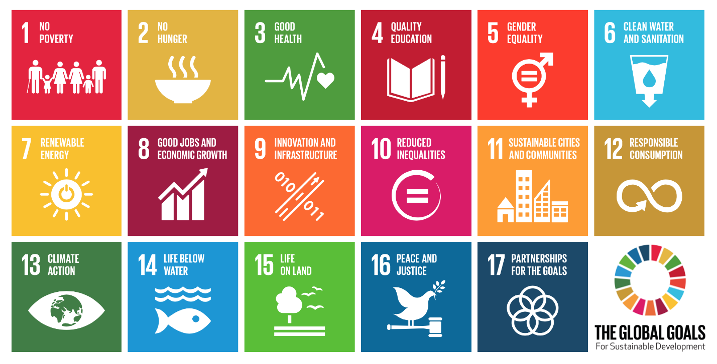
If Shan Yoma Travel and Tours wins the prize, we are committed and consistent to promote and collaborate with the region and the International to achieve the GLOBAL GOALS for Sustainable Development.

